**Hospital ERP Software**

**Project Synopsis**

**B. TECH (IDS353,ICS353)**

PROJECT GUIDE: SUBMITTED BY:

**Mr. Atul Yadav Abhinav Goyal (TCA2250001)**

**Akshat Jain (TCA2266002)**

**Bhumi Saxena (TCA22550004)**

Sepetmber,2023



**FACULTY OF ENGINEERING & COMPUTING SCIENCES**

**TEERTHANKER MAHAVEER UNIVERSITY, MORADABAD**

**Table of Contents**

1 Project Title ........................................................................................................................................... 2 2 Domain .................................................................................................................................................. 2

1. Problem Statement ............................................................................................................................... 2
2. Project Description................................................................................................................................ 3
   1. Scope of the Work......................................................................................................................... 3
   2. Project Modules ............................................................................................................................ 3
3. Implementation Methodology .............................................................................................................. 3
4. Technologies to be used ....................................................................................................................... 4
   1. Software Platform ......................................................................................................................... 8
   2. Hardware Platform ....................................................................................................................... 8 7 Advantages of this Project .................................................................................................................... 9

8 Future Scope and further enhancement of the Project ....................................................................... 9 9 Team Details ......................................................................................................................................... 9

1. Conclusion ....................................................................................................................................... 10
2. References ...................................................................................................................................... 10

# 1 Project Title

**Hospital ERP Software**

# 2 Domain

[A Hospital Management System (HMS) is a software application that manages the various aspects of a hospital, including patient data, appointments, staff records, billing, and insurance claims](https://www.leadsquared.com/industries/healthcare/hospital-management-system-hms/). [The domain model includes small but important substructures such as staff structure, hospital structure, patient treatment terminology, and relationship with patients](https://www.entcengg.com/class-diagram-for-hospital-management-system/).

# 3 Problem Statement

Existing System Challenges:

* High software development and deployment costs.
* Difficulty in migrating from manual processes due to staff and patient resistance..

**2**

* Overwhelming patient influx in government hospitals.
* Patient frustration with registration and data entry delays.

# 4 Project Description

The Hospital ERP Software is a vital information management tool that addresses the challenges faced by hospitals in the past. It facilitates the efficient handling of administrative, clinical, and financial aspects, leading to improved hospital performance. This system automates complex tasks, allowing staff to focus more on patient care.

Hospital ERP Software is tailored to the specific needs of medium and large-sized hospitals worldwide. It aligns with management principles, emphasizing healthcare quality and patient safety. It streamlines operations, enhances administration and control, improves patient care, controls costs, and boosts profitability.

Key Modules:

1. Patient Management
2. Services Management
3. Appointment Scheduling
4. List of Staff

This system plays a pivotal role in achieving predetermined hospital objectives, optimizing resources, and ensuring efficient healthcare delivery.

## 4.1 Scope of the Work

Scope of this system can be described as follows: -

It is a standalone module, available for desktop application used by computer Administrator to store data. The storing and retrieval of data is quick. It is an offline application. Access is given to only authorize person and no other person can access this software. Data security is maintained properly by authentication of users. Large amount of data can be processed quickly with ease

## 4.2 Project Modules

DETAILED LIFE CYCLE OF PROJECT

We have used Waterfall Model as Software Engineering life Cycle Process. It is the simplest; oldest and most widely used process model for software development. This model acquires its name from the fact that classic software life cycle is represented as a sequence of descending steps.

**3**

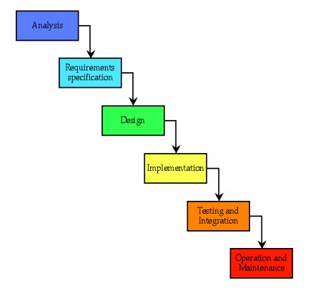

**5 Implementation Methodology**

### Login diagram

Open

login

form

Enter

username and

password

Send to the

user interface

### Sign-up diagram

Open

Sign-up

form

Enter username

and password and

other necessary

details

Send to the

Set

Appointment

**4**

### Level 1

Hospital ERP

Software

Admin

Patient

Staff

Login

Sign

-

up

**5**

Level 2

Admin

Login

|  |  |  |  |
| --- | --- | --- | --- |
| |  | | --- | | Permission | | |  | | --- | | Staff id and password | |

Database

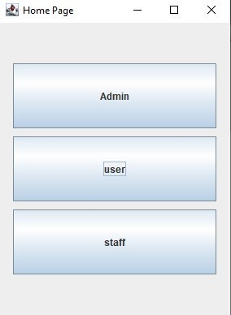

**6**

User

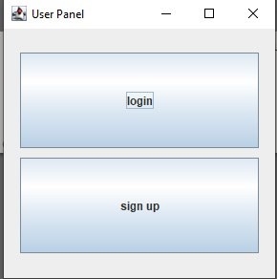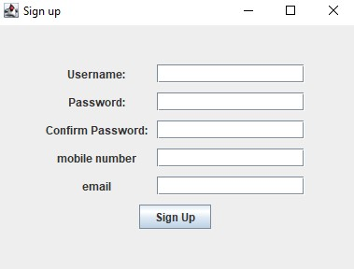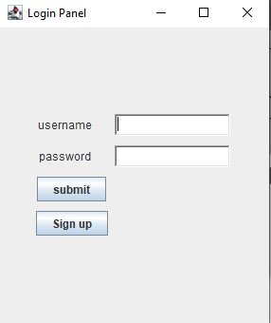

Admin

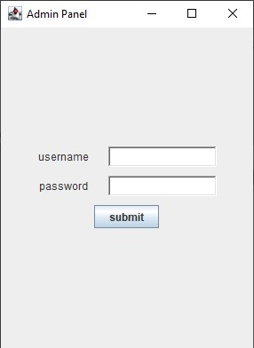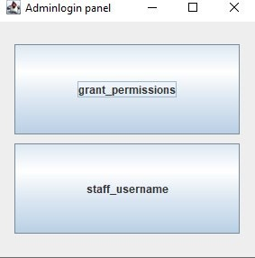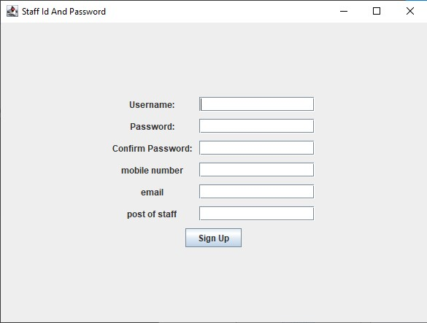

Staff

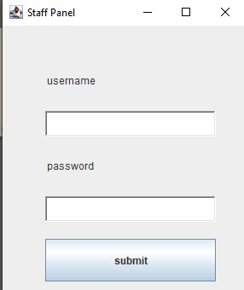

**7**

User database

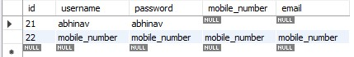

Staff Databases

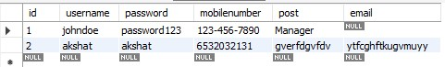

# 6 Technologies to be used

## 6.1 Software Platform

1. **Front-end:** JAVA SWING, JAVA AWT, JAVA, vs code ETC.

1. **Back-end:** MYSQL, JDBC

## 6.2 Hardware Platform

**Hardware Specification (Minimum):**

Disc Space: 10 GB

PC Used: IBM Compatible

Processor: Pentium 3

Memory: 512 MB RAM

File System: 32 bits

**Software Specification:**

Operating System (Server Side): Windows XP.

Operating System (Client Side): Windows XP.

Client side: Java application interface

Database: MySQL

**8**

# 7 Advantages of this Project

Proposed System Benefits:

1. User-friendly interface.
2. Streamlined project management.
3. Convenient remote access.
4. Enhanced patient care and operational control.

The proposed Hospital ERP Software aims to overcome existing challenges by offering a user-friendly, cost-effective solution that improves patient care and organizational profitability.

# 8 Future Scope and further enhancement of the Project

Scope of this system can be described as follows: -

It is a standalone module, available for desktop application used by computer Administrator to store Patient data. The storing and retrieval of data is quick It is an offline application. Access is given to only authorize person and no other person can access this software. Data security is maintained properly by authentication of users. Large amount of data can be processed quickly with ease

**Future Scope**

* Store Management
* Pharmacy Management
* Admission Management
* Ambulatory Care
* Laboratory Management

# 9 Team Details

|  |  |  |  |  |  |
| --- | --- | --- | --- | --- | --- |
| **Project Name** | **Course Name** | **Student ID** | **Student Name** | **Role** | **Signature** |
| Hospital ERP Software | B.TECH- CSE-  (In  collaboration  with INurture) | TCA2250001 | Abhinav Goyal | Developer,  Database etc. |  |
| TCA2250004 | Bhumi Saxena | Designing |  |
| TCA2266002 | Akshat Jain | Testing |  |

Page **9** of

# 10 Conclusion

The project entitled as Hospital ERP Software is the system that deals with the issues related to a particular institution.

This project is successfully implemented with all the features mentioned in system requirements specification.

The application provides appropriate information to users according to the chosen service.

The project is designed keeping in view the day-to-day problems faced by a hospital.

Deployment of our application will certainly help the college to reduce unnecessary wastage of time in personally going to each department for some information. Awareness and right information about any college is essential for both the development of doctor as well as patients. So this serves the right purpose in achieving the desired requirements of both the communities

# 11 References

Websites Referred

The following links were searched and exploited extensively for the project development and implementation.

* [http://www.stackoverflow.com](http://www.stackoverflow.com/)
* [http://www.oracle.com](http://www.oracle.com/)
* [https://www.w3schools.com](https://www.w3schools.com/)

Page **10** of **10**